**Assignment Day 4 | 23rd August 2020**

* **Question 1: Find out the mail servers of the following domain :**
* Ibm.com
* Wipro.com
* Answer: The process is explained in following steps:-

1. Open PenTester.vmx
2. Open Command Prompt
3. Type nslookup and press enter,
4. Then type settype=mx and press enter.
5. Then type ibm.com and press enter.

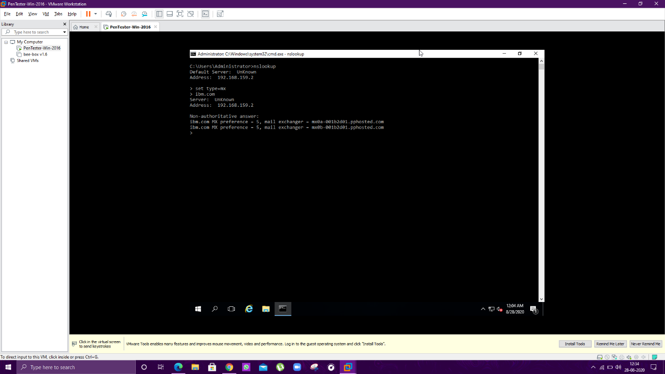

1. Then type wipro.com and press enter,

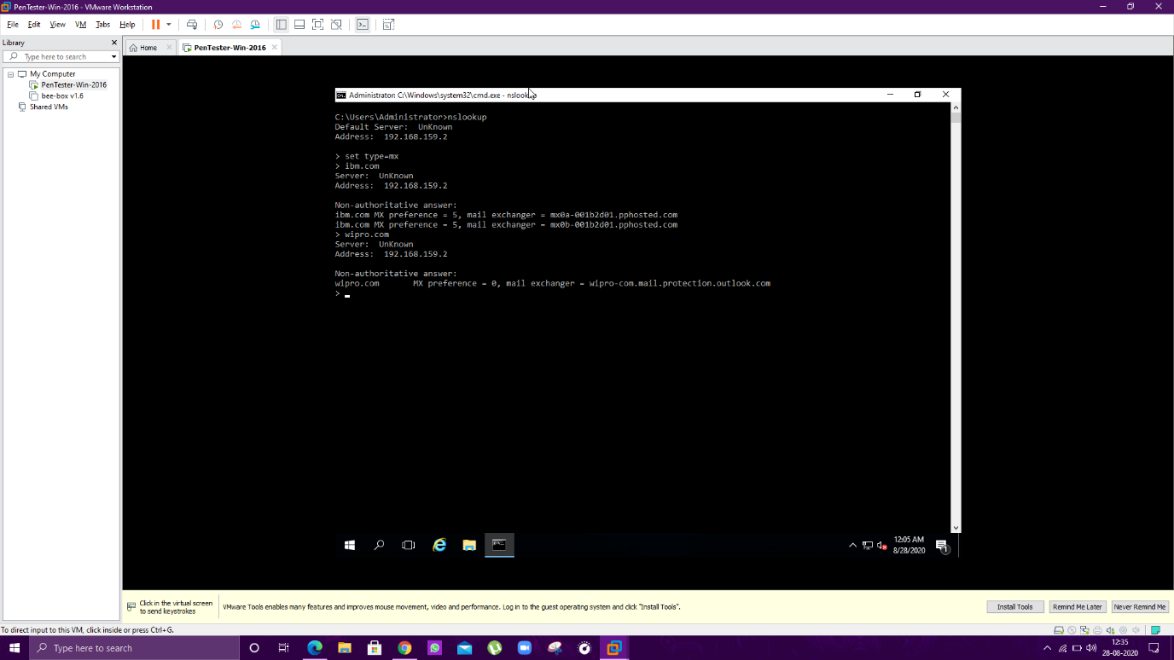

* **Question 2: Find the locations, where these email servers are hosted.**
* **Answer:** The Process is explained in following steps
* Use the app Email tracker Pro

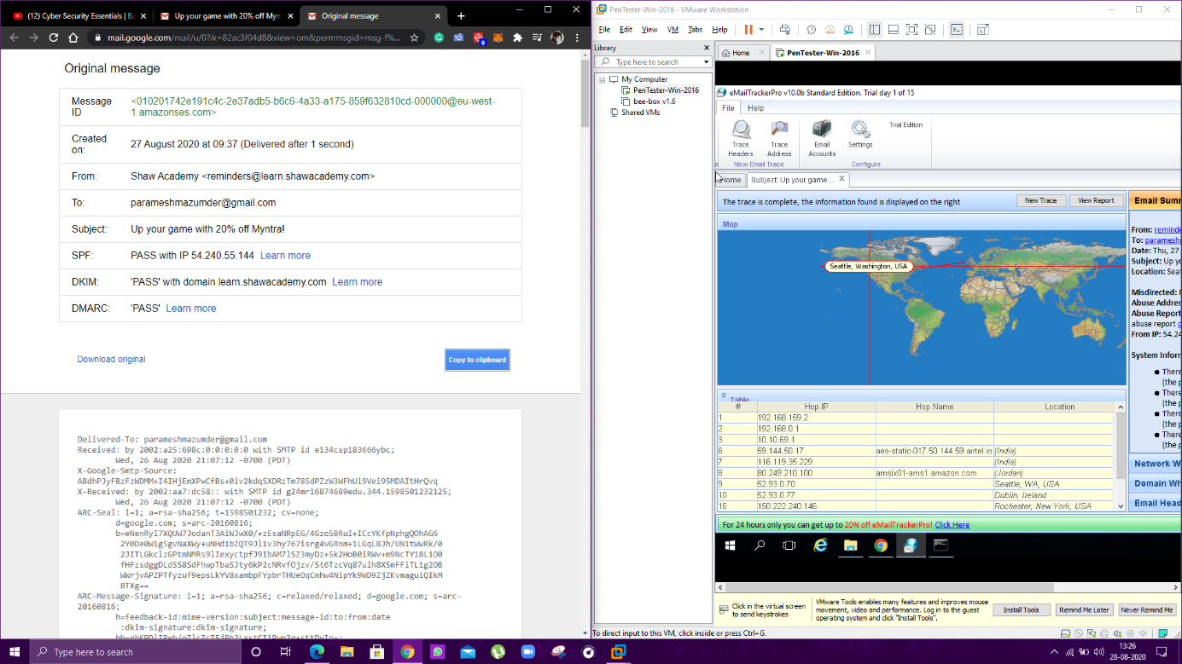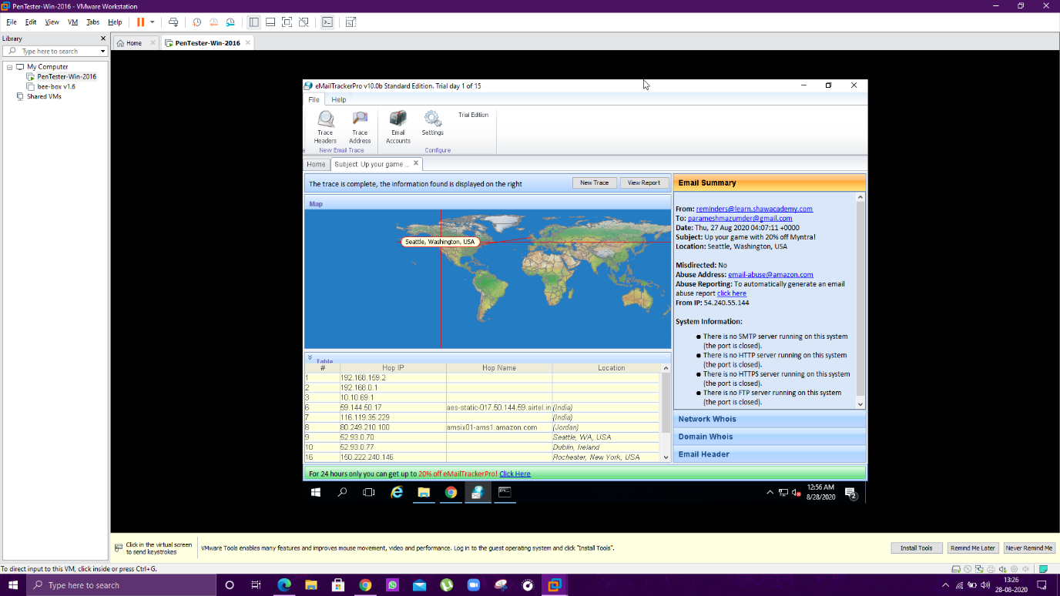

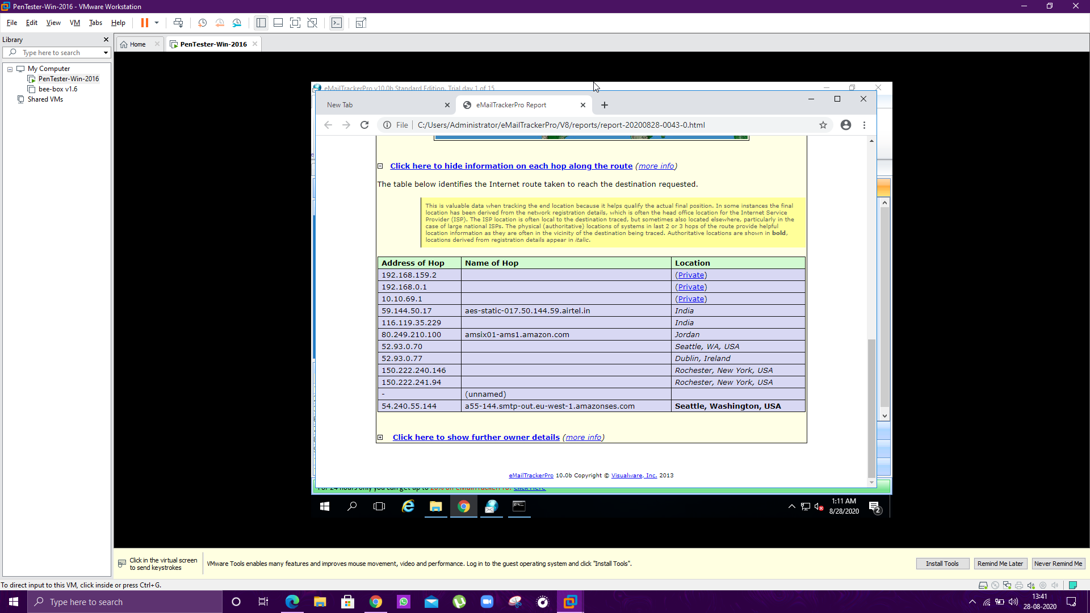

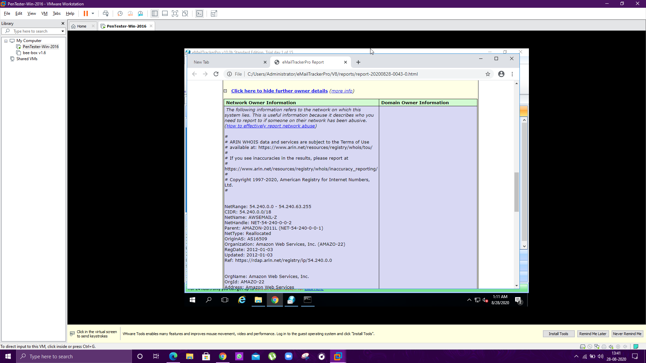

* **Question 3: Scan and find out port numbers open 203.163.246.23**
* **Answer:** The Process is explained in following steps

1. **Open kali.vmx**
2. **Open terminal emulator.**
3. **Type sudo su –**
4. **Enter the pass code.**
5. **Type nmap**
6. **Type nmap -Pn -sS -A -v 203.163.246.2**

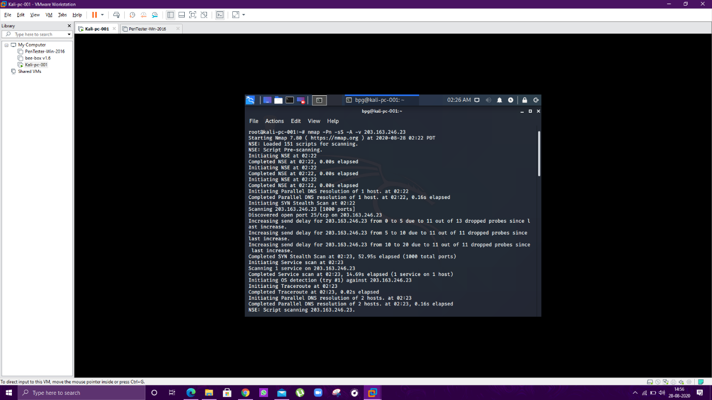

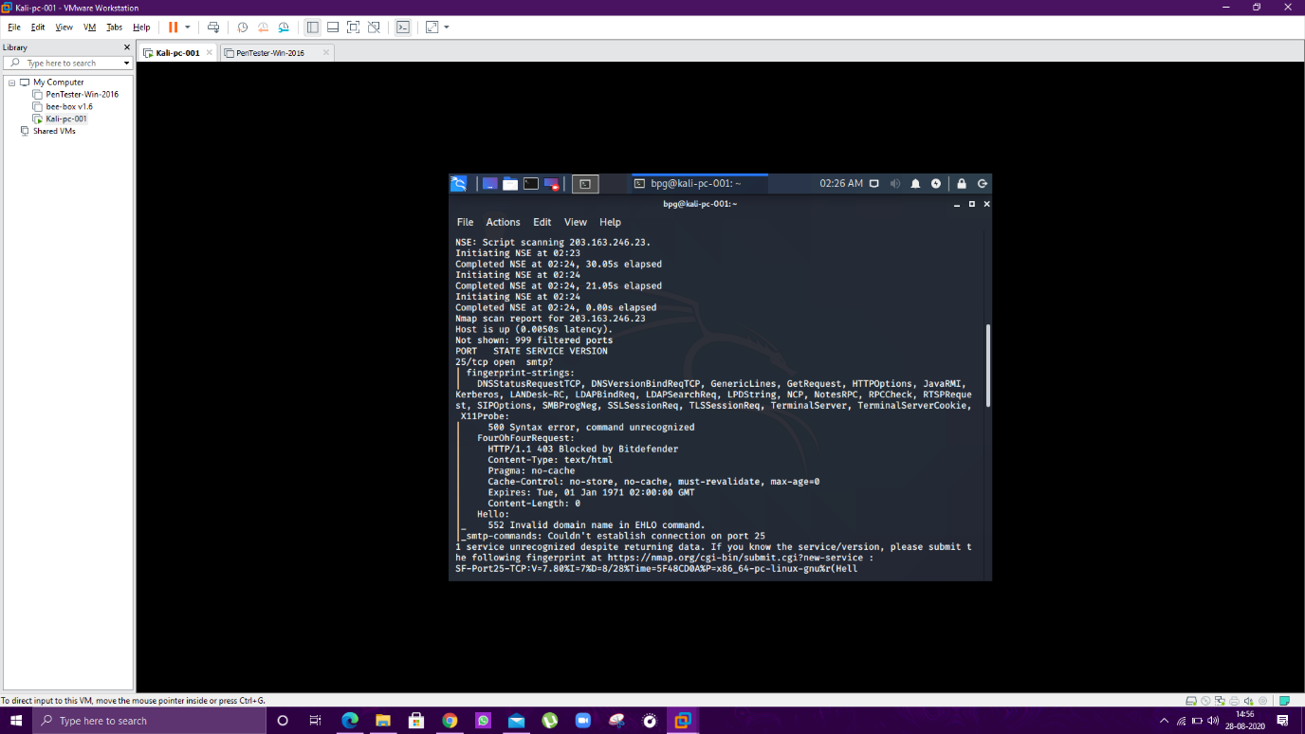

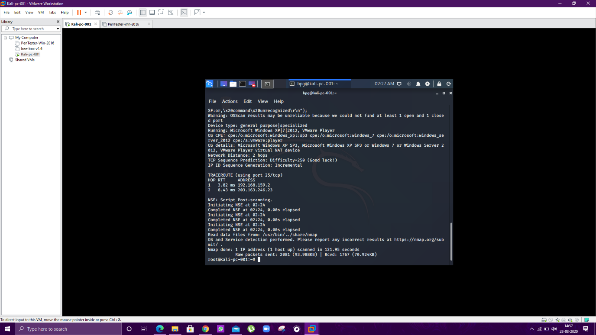

* **Question 4: Install nessus in a VM and scan your laptop/desktop for CVE.**
* **Answer:** The Process is explained in following steps.

1. Install Nessus App in VB.
2. Fill the required information.